

Lesson created by the GMU-ODU CSforAll Team. For more information about
this lesson and our CSforAll initiative, contact Dr. Amy Hutchison at achutchison1@ua.edu

Lesson 3: Decomposition & Abstraction |  | Grade Level: K

Concepts: Decomposition & Abstraction
Vocab:
- Decomposition
- Abstraction
Summary: In this lesson, students will decompose a story with a beginning, middle, and end, and abstract the story sequence by retelling it with coding blocks.
Lesson Objectives (learning targets): I can…

- Ask and answer questions about a story
- Retell a story with beginning, middle, and end
- Sequence a story with a beginning, middle, and end
- Put a story in the correct sequence
- Decompose a story into beginning, middle, and end
- Abstract a story sequence by retelling the beginning, middle, and end with coding blocks

VDOE English Standard(s) | Computer Science Standard(s)
K.1 The student will demonstrate growth in the use of oral language.  - Listen to a variety of literary forms, including stories and poems.  - Participate in a variety of oral language activities including choral and echo speaking and recitation of short poems, rhymes, songs, and stories with  - repeated word order patterns.  K.9 The student will demonstrate comprehension of fictional texts.  d) Begin to ask and answer questions about what is read.  e) Retell familiar stories, using beginning, middle, and end. | K.1 The student will construct sets of step-by-step instructions (algorithms) either independently or collaboratively including sequencing that emphasize the beginning, middle, and end.  K.2 The student will construct programs to accomplish tasks as a means of creative expression using a block based programming language or unplugged activities, either independently or collaboratively, including sequencing, emphasizing the beginning, middle, and end.

Materials
*See additional ideas for embedding today’s material in the last section of the lesson plan.

In preparation for this lesson, you will need the following:
- Teacher slide deck (see website)
- “The Itsy Bitsy Spider” Scaffolded Graphic Organizer
- Itsy Bitsy Spider CODING Scaffolded Graphic Organizer
- K Word Wall Cards

Lesson Structure and Activities
Warm-up/Bell Ringer Activity: (5-10 min)

NOTE: All slides for this lesson are scripted so that, if needed, you can see exact definitions and instructions for teaching this lesson in the notes at the bottom of the teacher slide deck.

Review Vocabulary with Emphasis on Patterns (Slides 6-8)

Introduction: (10 min)

- Review CS Concepts with Emphasis on Coding Block Commands

- Engagement & Interest: “Simon Says Coding Blocks Edition” (10 minutes; beginning on slide 10)

NOTE: Please think about any physical options that may be necessary to meet your students’ needs prior to doing this part of the lesson. It can be amended to fit all students' physical abilities!

- Walk students through slides 11-24, ask questions for them to share answers. Provide students an opportunity to unmute mics to share.

- Ask students to stand next to their desks or work spaces (even if virtual but still in sight of the camera). Prepare to play the Simon Says game together by acting out each ScratchJr command over the camera so that students can see what each action looks like “in person”(Slide 25) . Practice using slide 26 (Some students will only do the action one time. This is a great time to get to remind them to think about the number of times an action is occurring) and remind them to pay attention to the numbers on the block (Slide 27, 28).

- Start playing the Simon Says game (slide 29-38)

You can choose to stop between each of these slides or do them in succession depending on student needs. You can ask questions, like “How did you know that?” if some students are getting stuck and allow students to explain it to their peers.

NOTE: If you are a teacher who has chosen to teach this lesson across multiple days, this is a possible stopping point.

Guided Instruction: (15 min)

- Decomposition with Literacy

- (Slide 40). Introduce “decompose” and “decomposition”. Ask students to read Itsy Bitsy Spider together and pay attention to the beginning, middle, and end of the story and how the spider moves.

- (Slide 41) Display the “Itsy Bitsy Spider” poem as it appears in the slides where all students can read along, or write the poem on sentence strips.

Optional: Play The Itsy Bitsy Spider Song on Slide 41.
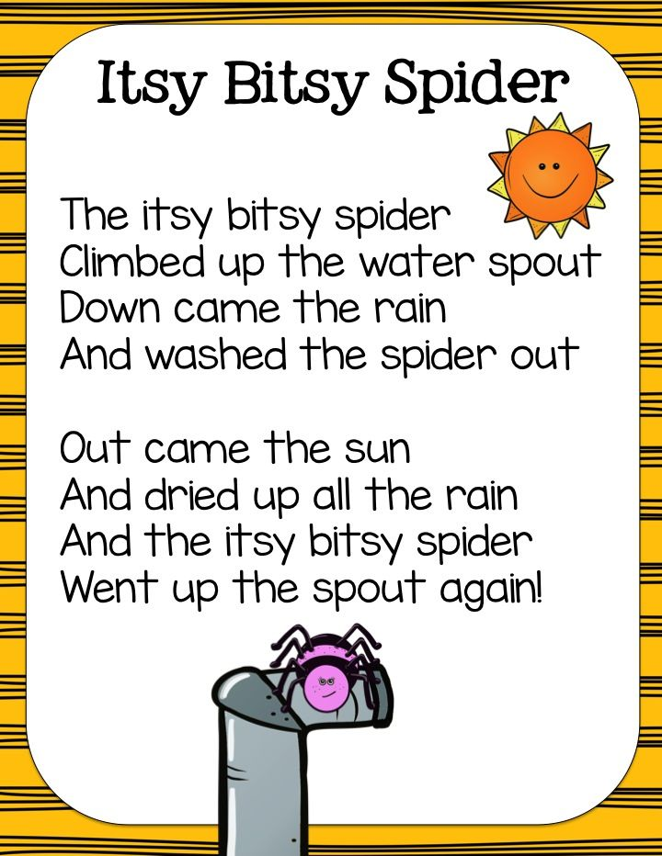

- Ask students to share how the spider moves at the beginning, middle, and end (slides 42-47). Wait time. Allow students to unmute and offer responses or type in chat. Use your fingers to give visual cues.

- (Slide 48) Review how we did a three finger retell to decompose the story. Wait time. If necessary, lift up a single finger like you’re doing a three finger retell to prompt students’ thinking.

- Introduce Abstraction

- (Slide 49-54): Use the questions about what types of breakfast students had this morning to demonstrate what abstraction is and why it is important.

NOTE: If you would like to do additional abstraction work with your students, you may use slides 79-89 for extra practice. These slides follow the same discussion pattern used as the “breakfast” abstraction slides.

- Reinforce Coding Blocks

- (Slide 55). Display the coding blocks on the slide. If time permits, show students the different coding blocks available using the ScratchJr Blocks document.

Prompt students to notice that the color of the blocks indicates a type of function (e.g. blue motion blocks, yellow triggering blocks). Connect to the concept of abstraction.

NOTE: If you are a teacher who has chosen to teach this lesson across multiple days, this is a possible stopping point.

Guided Practice: (30 min)

- Linking Literacy and ScratchJr Commands

- (Slide 57) For this section, we suggest the Itsy Bitsy Coding Graphic Organizer. If students need additional practice, they can use the Itsy Bitsy Spider Abstracting Graphic Organizer prior to this lesson. For this section, give students a choice of whole group, small group, partners, independent work.

Now using the coding blocks to abstract the story

Using the graphic organizer, ask students to cut out the parts of the story in the green boxes and glue them in the dark purple boxes.

Give students time to cut and glue OR use the scaffolded version of the graphic organizer (same graphic organizer - different page) that already has this step complete.



- (Slide 58- 59) Use the blocks to think about the ways that the spider moves. Prompt students to review what each block does. This can be done in small groups and then reviewed as a whole group activity.

- (Slide 60-72) Guide students step by step to choose the right block for the spider’s move. Ask questions and allow wait time. Provide students an opportunity respond. Show students visual cues to evoke their memory.

Wrap up: (2 min)

- Review Concepts and Vocabulary using slides 74-75: decomposition, abstraction, using blocks to retell a story
Assessment Strategy:
Multiple formative assessment moments exist in the present lesson:
1) The Simon Says game is a good place to check for student understanding of the commands.
2) The breakout groups or whole group activity is a good time to check student understanding of the decomposition and abstraction processes. 3) The graphic organizers may be uploaded prior to the lesson for students to complete in real-time during the lesson.
4) Check for students’ (a) retelling parts of the story to guide their thinking, (b) showing evidence of abstracting the sequence one step at a time, and (c) using the correct coding blocks to show the corresponding movements of the spider.

Extension Ideas: | Art: Most arts and crafts activities naturally follow a beginning, middle, and end sequence. During your arts and crafts time, or while leading an arts and crafts center, explicitly teach students that they can practice decomposition with their art, deciding on what to do next, one step at a time.  P.E.: Play a game of “follow the leader” in sets of 3 (e.g., hop, step, jump). Prompt students to abstract, or retell, what action was done at the beginning, middle, and end of the sequence, either by describing it or acting it out. To incorporate the coding blocks, have the student leader place a set of coding blocks in order for other students to follow (ex. up arrow = jump, down arrow = touch your toes)  Music: Young children typically enjoy clapping games that require observation, mimicking of the sound pattern, and opportunities to lead the patterns themselves. Using the coding blocks, model a clapping pattern for them to copy (up arrow = clap up high, down arrow = clap down low, etc.). Prompt students to abstract which sounds were done at the beginning, middle, and end of the sequence, step by step.  Writing: Decomposition and abstraction can be embedded in Kindergarten writing through the creation of How-To books. Add simple 3-page booklets to the writing center, allowing students to create their own 3 step How-To books with a beginning, middle, and end. Then, teach students how to draw arrows to show which direction their characters are moving in the pictures. Embed ScratchJr command icons in literacy by using the arrow commands to show character actions.  Science: Decomposition can be easily integrated into units on animals, weather, and life cycles. Embed decomposition vocabulary into lessons (e.g. “In the beginning, the butterfly lays an egg and a caterpillar hatches… In the middle, the caterpillar eats and eats and turns into a chrysalis… In the end, the butterfly comes out of the chrysalis.”) Encourage students to further decompose each piece by looking closely at the smaller changes that happen within each step of the process.  Math: Kid-friendly cookbooks are an interesting, authentic place for children to see not only abstraction through steps, but also numbers and measurement. Consider adding cookbooks to the kitchen area during dramatic play. Embed in ScratchJr grid (Slide 78) in math (e.g., overlay a grid that fits patterns and use the grid blocks to help show how large or small a pattern gets). We look forward to hearing how you have embedded abstraction into literacy and across your other content areas at our next meeting! Embed ScratchJr command icons in math and/or science by using the up/down arrows along with addition and subtraction  Social Studies: Community helpers often have uniforms that tell people how they help. Show children pictures of community helpers. What are the jobs of these helpers? How do they get ready for their job, step by step? Embed the ScratchJr grid (Slide 78) into other domains such as social studies (e.g., you could overlay a grid over any map you are using and use manipulatives to show how far your historical figures traveled)  Reading: Acting out stories through readers’ theater allows students to see how a character moves throughout a story. Where are the characters’ hands and feet? What are they doing? Encouraging students to act out stories will allow them to think more deeply about how they want their characters to move when they use the coding blocks and ScratchJr.  Social-Emotional:  For social-emotional and classroom connections, use the ScratchJr. commands to express feelings and ideas. For example, in morning meeting, you could use the “loop” command icon to show that we “try again”. You could use other command icons such as the “green flag” and “stop” (and or the grid concept) to tell stories or at exits/entrances/or as floor tape to maintain social distance requirements in your classroom. If your whole school is involved, it would be great to place these commands at doorways to other areas in the building. Be as creative as you like! You can also use the ScratchJr commands as a way to continue to build student capacity by adding ScratchJr command blocks to the Simon Says game and playing it intermittently before the next lesson.  Rationale:  Explicitly embedding vocabulary is an essential component of sequencing instruction. Young learners need repeated exposure to vocabulary in order to internalize the “flow” of stories and events
Alignment: | This is the third lesson in the unit. Lesson four is Algorithms.
Supplemental Resources: | Decomposition and abstraction can be challenging skills to teach. Please see this video if you need additional support in how decomposition is used in ScratchJr.

